[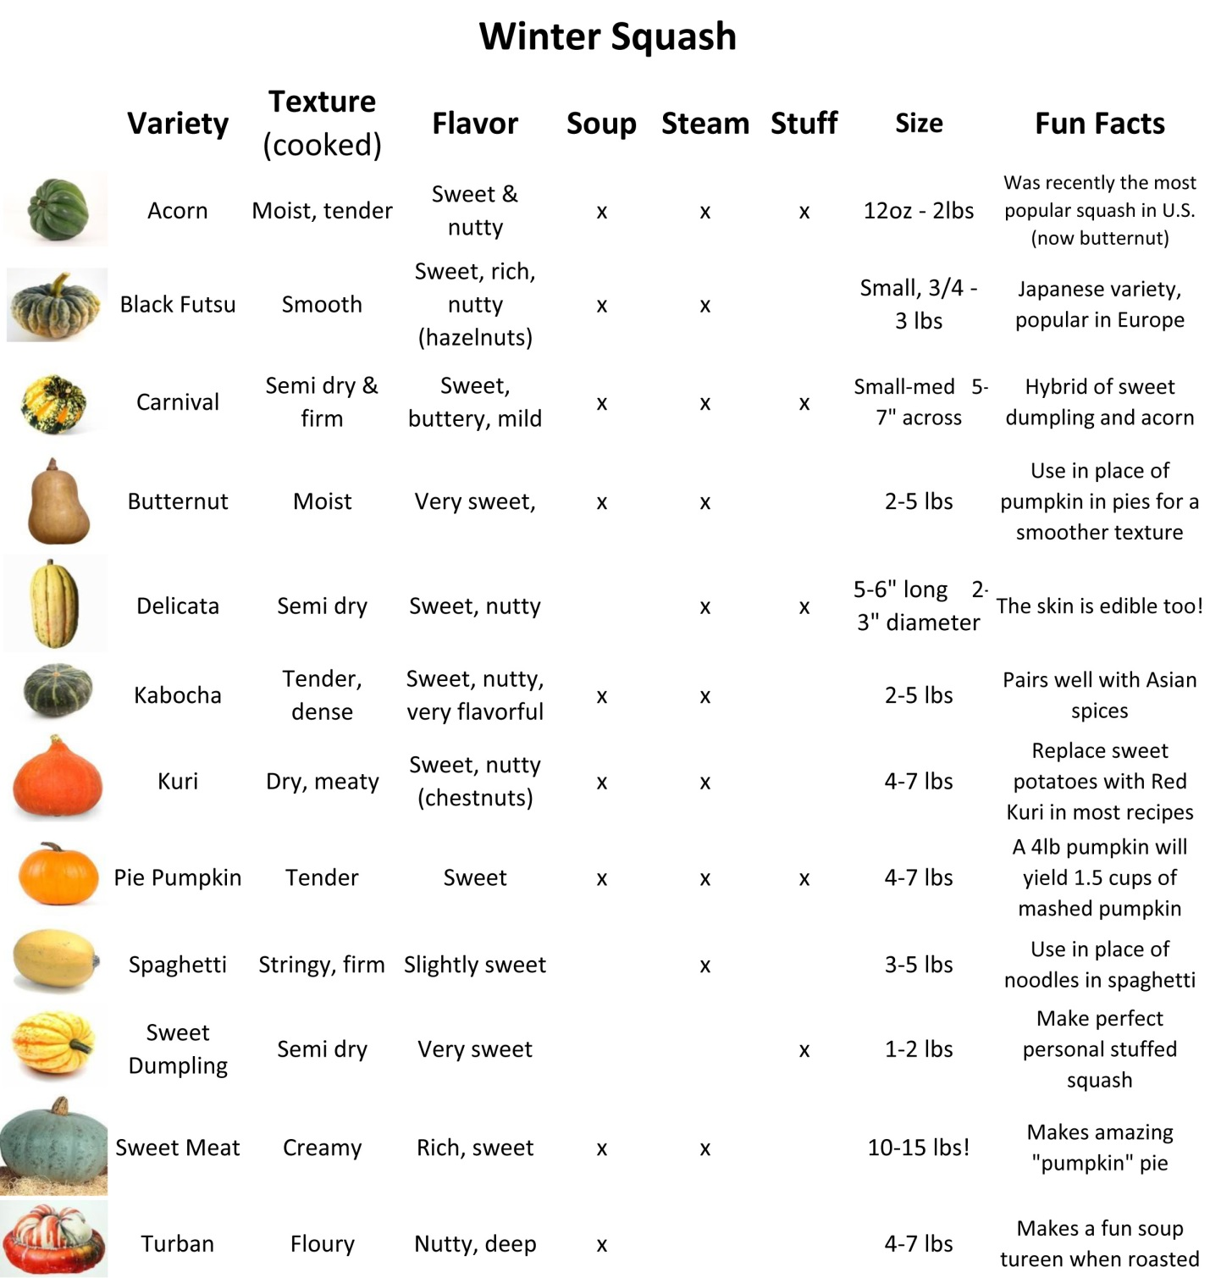](http://www.astoria.coop/wp/wp-content/uploads/Squash-varieties-chart.jpg)